**Working Title: The Black Samurai.**

**Concept:**

A fast paced action game that picks up speed and intensity with progression.Player controls a sword wielding samurai a fight to free Japan from the rule of a tyrant emperor. Gameplay will consist of a combination of elements from various older side scrolling platform games.

**Genre and Inspirations for the game mechanics.**

Primarily an Action/adventure platform/indie game. This game would specifically be classed as a side scrolling beat’em’up. Originally Inspired by Double Dragon 3 (Super Nintendo), it will involve the camera following the character through levels containing lots of enemies that the player must defeat with melee attacks. Double Dragon 3 was one of the 1st games of its kind to employ a more complicated fighting mechanics were players could grab, flip and thro enemies around using the same button. Variations of attacks were performed by timing your actions accordingly and combining with direction controls. Similarly timing attack coordination will be a major part of the fight mechanics but are not confined to scripted actions. Level design and physics inspired by Sonic the Hedgehog (Sega Master System), involving multiple platform levels that line up with trajectories that the character can only reach after picking up speed from running down hills. Secrets and special items can be obtained from reaching these platforms.

**Target Audience and Platform Deployment.**

Designed to be easily picked up by anyone this game is targeted at a large variety of ages and backgrounds. The casual gamer that likes to jump right into some action without having to get to heavily involved.

This is a violent game so will likely to attract males of between the ages of 13 and 25. The older experienced gamers will also be attracted as it will provide some nostalgic resemblance to the classic platform games they grew up with.

Initially the target platform will be windows/steam and mac. Android IOS and console versions of the game will be released after feedback is received from desktop users.

**Treatment. 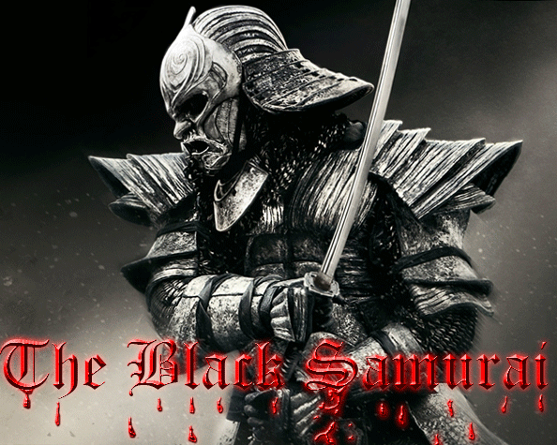**Figure 1: Concept for game.

You are the Black Samurai. A once honourable warrior turned assassin. You have gone down the dark path for too long and seek to regain your honour.

Compelled by moral conflict you turn on your employers to defend the victims of a tyrant’s ambition.

It’s time to step out of the shadows and openly take on the entire imperial army!

* Fast paced sword fighting action.
* Multiple Weapons.
* Intensity that increases with each level.
* Defeat an entire army!

**Concept Art.**

Figure 1 show the game cover concept illustrating the overall feel of the game to be a dark and violent one. The game will feature a level design that makes use of the player’s ability to pick up speed to reach various platforms as illustrated in figure 2. Character will be constructed with traditional style samurai outfit with a black finish as shown in Figure 3. 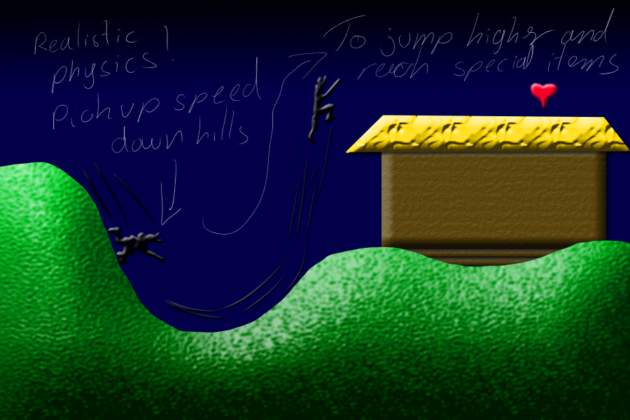  
Figure 2: Physics and level interaction.

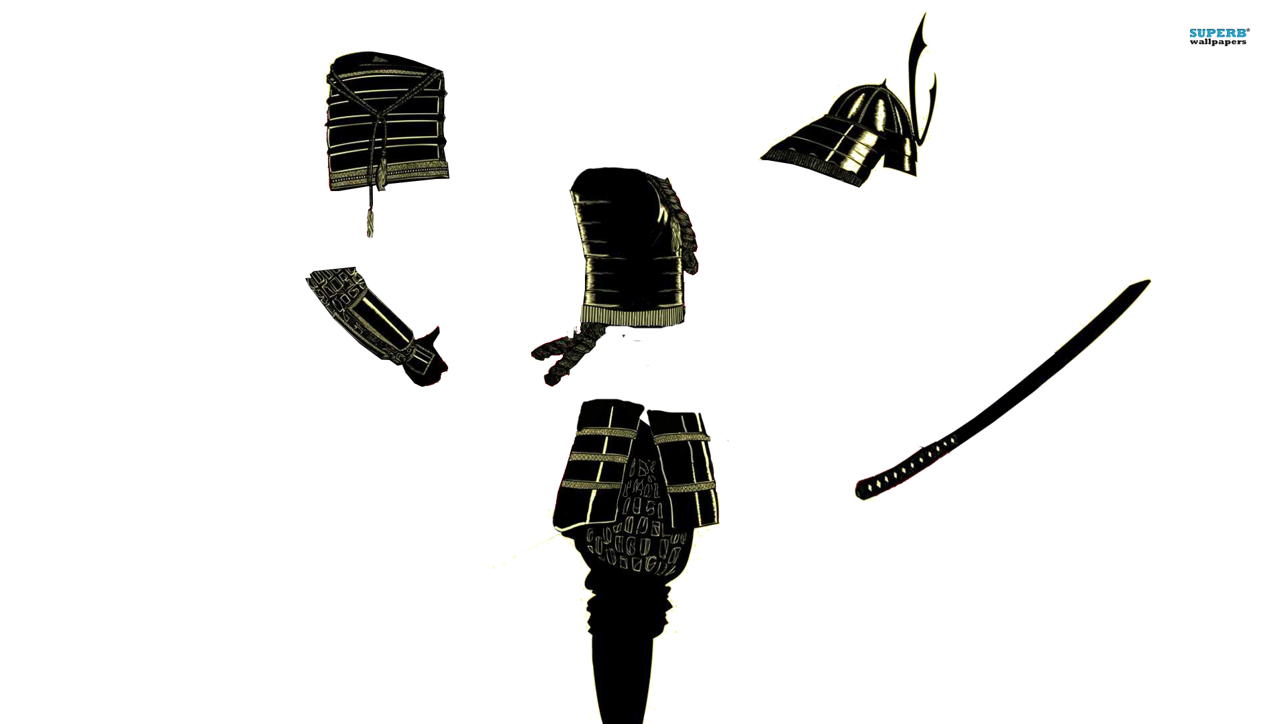

Figure 3: Early character construction.

**References: Sources used for concept art.**

<http://artemisdefenseinstitute.com/Blog/3261659>

<http://www.hardcoregamer.com/2012/10/03/playstation-mobile-now-available-on-vita/14775/>

<http://www.gaksdesigns.com/The-Headless-Samurai>

<http://www.history.com/topics/samurai-and-bushido>